

**END OF TERM ONE EXAMINATIONS 2023**

**BABY CLASS**

**HEALTH HABITS**

NAME_______________________________

1. Trace the mouth.
2. 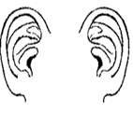Match the same body parts.

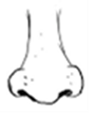

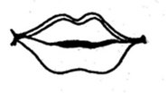

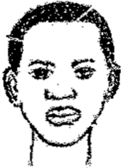







1. Colour me please.
2. Draw again.

|  |  |
| --- | --- |
|  |  |

1. Tell the body parts.



